* Chỉ hoạt động với JPA 2.1
* **Using @Enumerated**
  + **Ordinal value (thứ tự)**

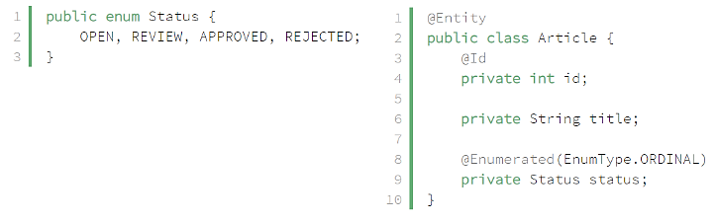

*Enum & Entity*

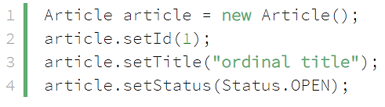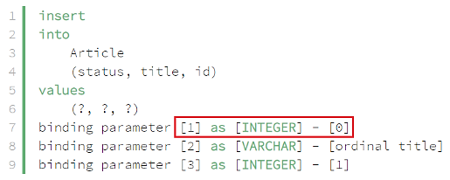

*Using*

* + **String value**

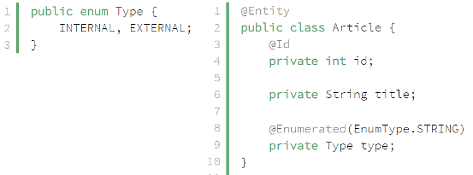

*Enum & Entity*

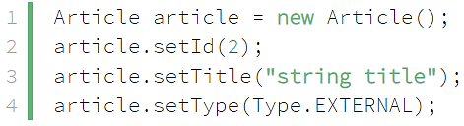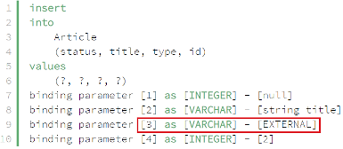

*Using*

* **Using @PostLoad and @PrePersist**

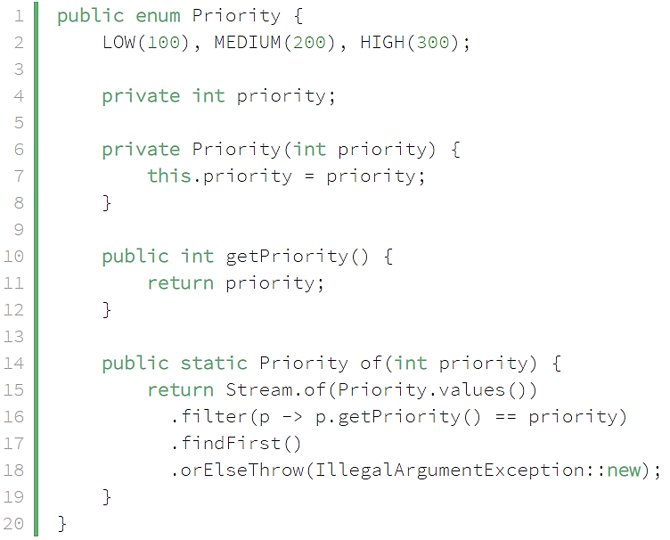 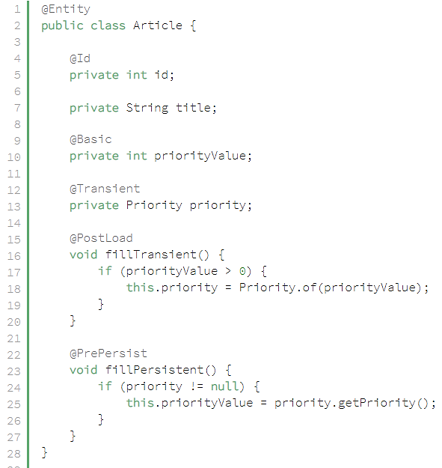

*Enum & Entity*

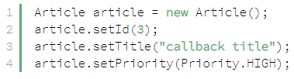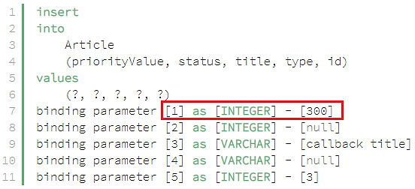

*Priority.of() method to make it easy to get a Priority instance based on its int value.*

*Using*

* **Using @Converter**
  + **VD1:**

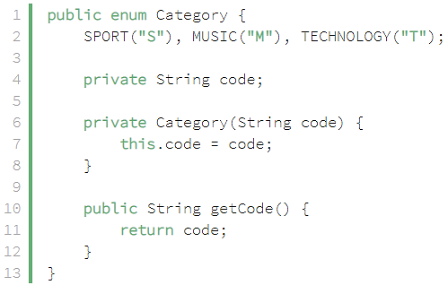 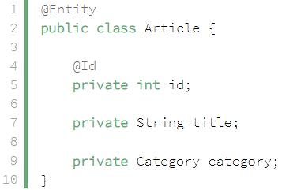

*Enum & Entity*

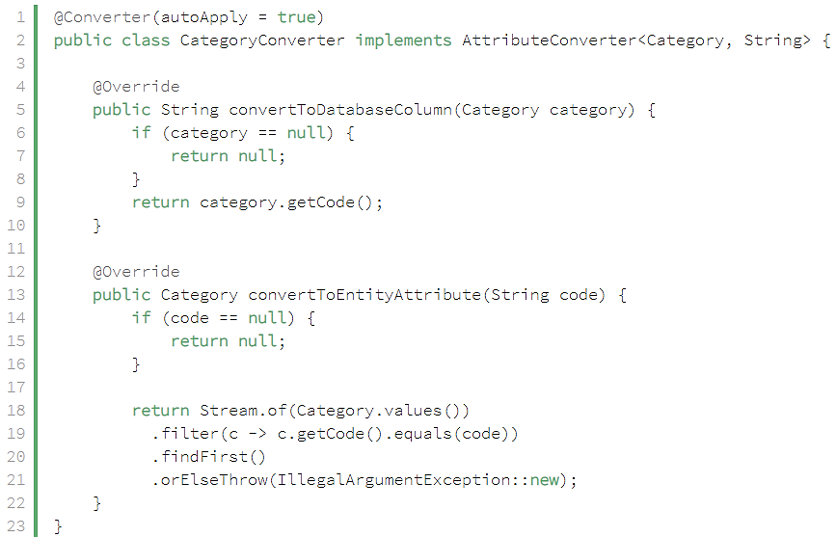

*@Converter(autoApply = true) nghĩa là sẽ tự động apply convert Category type*

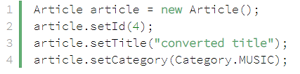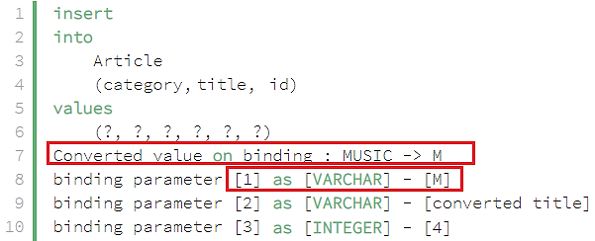

*Using*

* VD2:

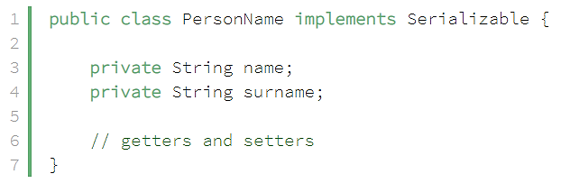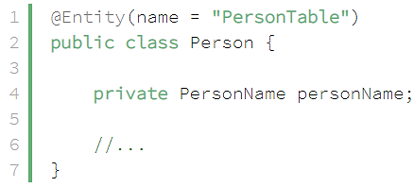

*Enum & Entity*

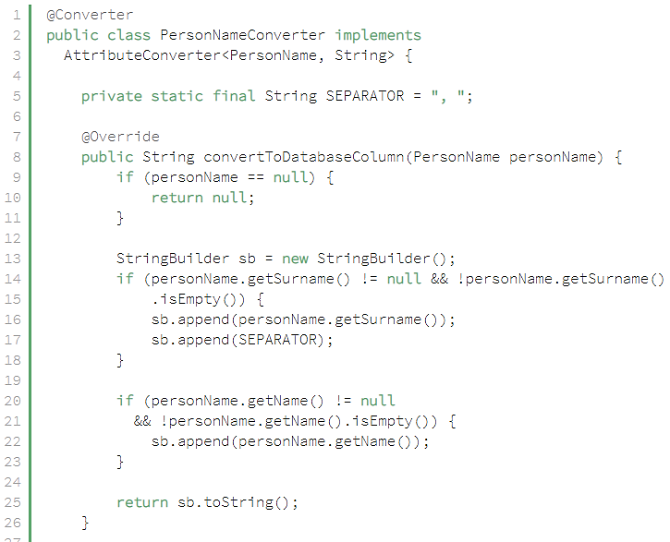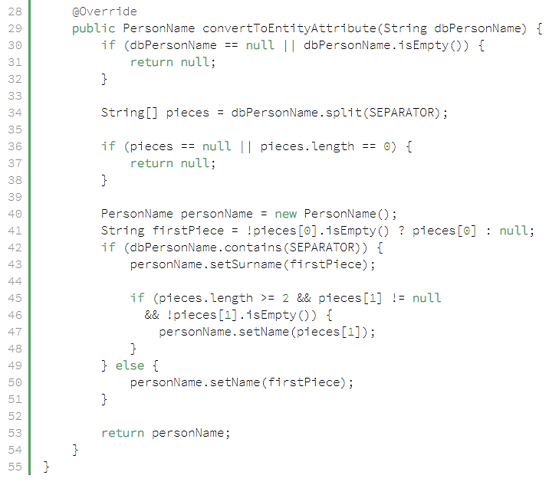

*File convert*

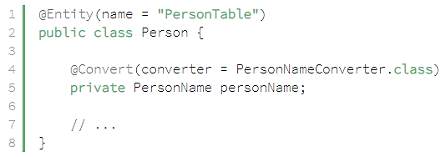

*using*

[*https://www.baeldung.com/jpa-attribute-converters*](https://www.baeldung.com/jpa-attribute-converters)

* **Reference**

<https://www.baeldung.com/jpa-persisting-enums-in-jpa>